Day Visitor Information Sheet

Gate
The reserve trading times for day visitors are as follows:
- October to March - 6am until 6pm
- April to September – 7am until 5pm
Please ensure that you depart from the reserve at the stipulated closing times.
Lastly please bear in mind that if we receive more than 30mm of rain the evening before or the day of your arrival, kindly note that the reserve may be closed or self drives restricted.

Entrance fees

Vehicle | R70-00
Combi/Quantum (18 max) | R160-00
Sprinter | R260-00
Bus (30 seats or more) | R360-00
Adult | R60-00
Child ( 3yrs – 12yrs) | R50-00

Please ensure that you abide by the rules and regulations of the reserve. If any person or persons caught contravening these instructions, we will have no option but to impose a fine or eviction from the reserve.

Game Drives
All game drives are 2 hours long and please ensure that you arrive at reception 15 minutes before departure. If you are late, you will be moved to another time-slot and that may also depend on availability.
Departure times:
- October to March: 8am, 10am, 2pm and 4pm
- April to September: 9am, 11am, 1pm and 3pm
- Game drives for 1 person is not permitted unless he/she pays for the second seat.

Groups of between 2-9pax | R295-00 an adult, R195-00 (5yr – 12yr)
Groups of 10 pax or more | R275-00 an adult, R195-00( 5yr – 12yr)

Please note for safety reasons the following persons are not allowed on the game viewer:
- Children under the age of 5 years
- Woman in pregnancy of 6 months or more.
- Persons older than 75yrs
Please bear in mind that if we receive more than 20mm of rain either the evening before or on the day of departure, you will be notified that all game drives may be cancelled for the day.

Bush Walks
- All walks depart from reception which is located at Aloe lodge.
- Please ensure that you arrive 15 minutes before departure.
- We suggest that wear jeans or long shorts with a good pair of closed walking shoes. Each walker will receive bottled water.
- One ranger is allocated to a total of 8 hikers.
- Booking of bush walks must be booked at least 72 hours in advance

Groups of 2 pax to 8pax | R195-00 a person (12yrs and older)

Please note that if we have rains or thunderstorms all walks will be cancelled

Other Activities:
- Hot air ballooning
- Clay-pigeon shooting ( Eston Club)
- Sky Diving ( Durban Sky dive located across from Tala)
Rockpools – public picnic and braai area
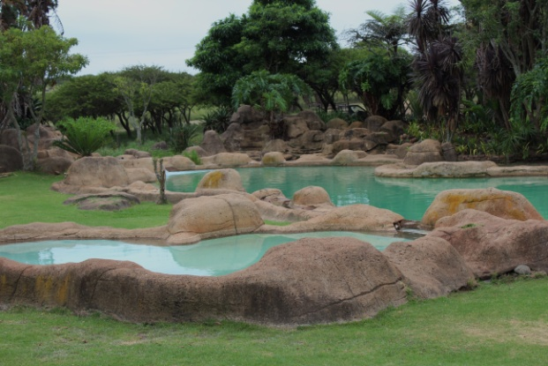
This area is located on the far right of hippo dam and is ideal for day visitors who would like enjoy a picnic under the Acacia trees.

Restaurant at Aloe Lodge
Trading hours
Breakfast:
- Monday to Sunday: 8am – 10am
Lunch
- Monday to Saturday: 10am – 5pm
- Sunday: 12noon – 3pm (Sunday Buffet)
Dinner
- Monday to Saturday: 6pm – 8pm

Whether it is a conference, over-night stay or a wedding please email the following for more information:

Conferences: conferences@tala.co.za
Weddings: wedding@tala.co.za
Accommodation: reservations@tala.co.za
Information: reception@tala.co.za

Contact details: 031 781 8000

